**Website Development Agreement & Description**

**Agreement**

A formal request is being made to have a website developed for Tranquility Getaway Ltd. represented by Ms. Astrid Lindberg in her capacity as Manager, by Mr. Tadj A. D. Cazaubon. It has been previously requested that Mr. Cazaubon remove the old site which was registered as ‘tranquilitygetaway.com’ due to it being insecure, and he has obliged out of good faith, providing consideration to this agreement.

It has been agreed by both parties that the site will be constructed by Mr. Cazaubon as requested herein, for the amount of $1,500.00 EC dollars, and shall remain the property of Tranquility Getaway Ltd.

**Description**

A website following the below shown design must be constructed to allow potential clients the ability to access Tranquility Getaway’s services via the domain names: **tranquilitygetaway.lc** and **tranquilitygetaway.co**

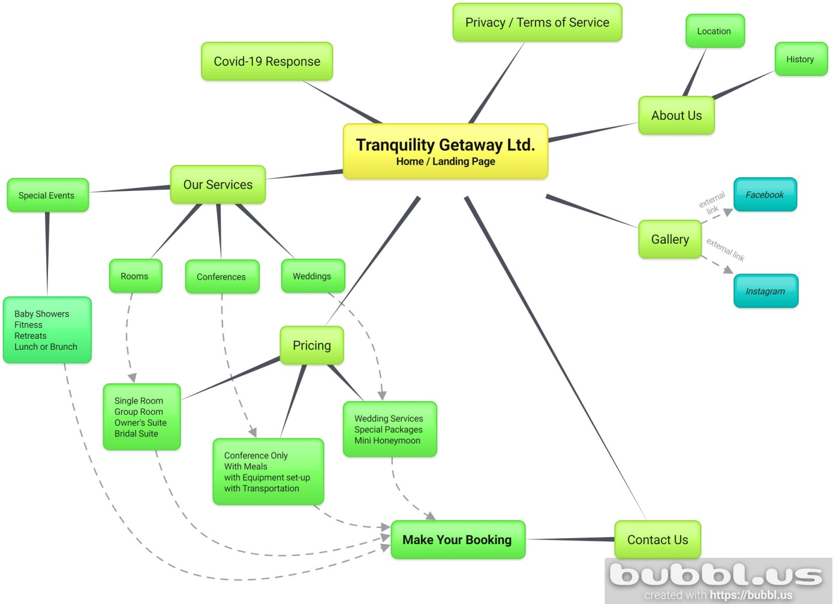

Script for each of the Extensions given:

**About Us - Location**

Tranquility Getaway is a 3-star apartment style hotel, which offers 12 air-conditioned self- contained apartments, an outdoor pool, conference center and rooftop terrace.  The property is located at Morne Fortune, which is just 15 minutes outside of the main city of Castries in a residential/commercial community and is able to provide guests with a peaceful, relaxing environment, away from the noise of the city. This area is rich in historic sites including the resting place of Sir Arthur Lewis (One of St. Lucia’s Noble Laureates), the Iniskilling Monument, Old Forts, Army Graveyards and Prisons, Underground Barracks, etc.  It is also in close proximity to basic amenities such as supermarkets, pharmacies, hardware stores, public and private hospitals and the Anse Fere Beach.

**About Us – History**

First opened in 2007, Tranquility Getaway Ltd began with just 8 single and 4 group apartments, one of which belonging to the owner and his family. They focused primarily on business travelers and families travelling with elderly persons or small children, who needed ramps to access their rooms. Renovations over time allowed the addition of the pool and Bridal Suite as well as and upstairs event space. Over time, one of the group apartments was transformed into a restaurant and kitchen and further expansions also led to construction of a rooftop event space and conference room. These renovations took almost ten years in all to complete, but allowed Tranquility Getaway the ability to reach a wider market, adding event and conferencing services to their endless ways of creating special moments.

**Privacy / Terms OF Service**

The following Terms of use are in place

1. The lead guest must be at least 18 years old at the time of check-in.

2. To secure or confirm your booking, a deposit must be paid equal to 50% of your entire stay.

3. Guests must check out before 12 noon and return their key to the office. If you require a late checkout, please ask reception if this can be accommodated. Late checkouts require an additional $50.00 EC be paid for the extra time and can only be extended up to 4 pm.

4. Cancellations are allowed without penalty up to 48 hours before check-in time. Any cancellations made after this time will be charged 50% of the original booking plus all applicable taxes.

5. Tranquility Getaway Ltd. reserves the right to cancel your booking without compensation, refund or reimbursement if any of these conditions are not upheld.

6. Failure to show up or non-arrival of guests without communication or cancellation, forfeits any and all deposits made.

7. Refunds: will be issued to guests within 30 days where applicable in the same manner in which the payment was made.

8. Damages: We reserve the right to charge the lead guest for any damages caused throughout the course of your stay by any member of your party. This includes breakages, stains and damage to furniture, damage to fixtures and missing items. Any accidental breakage must be reported immediately to the office staff or the security guard on duty in an effort to avoid this charge.

9. Lost keys will be charged a replacement fee of $20.00 xcd.

10. Smoking is prohibited in the rooms and will incur a charge of $250.00 xcd to be paid by the lead guest. Smoking can be done in the verandas or any of the open spaces on property.

11. Absolutely No pets are allowed on property.

12. Guests parking in the on property parking lot must first accept that they park at their own risk.

**13. COVID19 DISCLAIMER:** I agree that Tranquility Getaway Ltd. as the legal right to keep my credit card information on file, for the duration of my stay, in the event I, or anyone in my party, develops symptoms of n-COVID19 Virus and needs to be quarantined, during or beyond the time of my booking. I agree that in this instance, to accept the cost of their quarantine including the cost of the room, food and beverages, medical testing and any other cost which may arise directly from me or anyone in my party, being quarantined at this establishment.

14. We are required to keep a register of guests over the age of 16 who stay with us, this includes full names and nationality, and/or passport numbers, place of issue, details of next destination if they are non- British, Irish or Commonwealth guests. This is in accordance with the (Immigration (Hotel records Order 1972). These records are kept for a minimum of 12 months and in accordance with the DPA (Data Protection Act 1998) and the GDPR (General Data Protection Regulation).

15. We are also required to keep personal information in the event of n-COVID quarantine and the need to perform contact tracing for up to 14 days after your departure, for all persons in your group.

Additional Waivers and Agreements (See Attachments):

1. Agreement Waiver For Guests COVID-19
2. Pool Disclaimer

**Covid-19 Response**

Covid-19 is an infectious disease caused by the SARS-CoV-2 virus. It was detected for the first time in Wuhan, Hubei province, China, at the end of 2019. Given its rapid expansion, the World Health Organization (WHO) declared a state of sanitary emergency on 30th January 2020; a month and a half later, specifically on 11th March 2020, when the disease had surpassed the epidemic situation, it declared a state of pandemic ([Rodríguez-Antón](https://sciprofiles.com/profile/409648), & [Alonso-Almeida](https://sciprofiles.com/profile/172777), 2020).  Whilst closing of international borders and other measures like quarantines, curfews and social distancing have slowed the spread in some instances, this has caused an economic crisis worst felt in countries relying on tourism and travel as a revenue source.  This economic downturn has led many governments enacting phased plans for reopening with Covid-19 specific regulations which will replace historic travel protocol. World Travel & Tourism Council, at the end of May 2020, developed a series of protocols to reactivate safe tourism in the world (WTTC, 2020)  The protocols to be applied in hotels, take into account World Health Organization (WHO) and the United States Centers for Disease Control and Prevention (CDC) guidelines ([Rodríguez-Antón](https://sciprofiles.com/profile/409648), & [Alonso-Almeida](https://sciprofiles.com/profile/172777), 2020). The objective is to ensure that protocols are in place across all relevant functions with an increased focus on health, safety and social distancing guidance which travelers will need and expect (Rodríguez-Antón, & Alonso-Almeida, 2020).

Tranquility Getaway Ltd. in response to these new protocols went straight to work. Implementing their Coivd-19 Action Plan and developing specific strategies aimed at sanitation, education and safety. All of Tranquility Getaway Ltd.’s employees were trained in Covid-19 response, cleaning, sanitation and the new requirements for keeping guests, themselves and their loved ones safe. This training was very detailed and covered new laundry and housekeeping procedures, new check-in and check-out procedures, new procedures for employee general areas and even ways to keep safe on your way to work and home. Structural changes have been made to our reception area and system changes have been employed to allow transactions to be cashless. The entire property has undergone an upgrade to allow all areas to be sanitized daily with the addition of sanitizing hand wash in all guest rooms, staff areas and public washrooms, sanitizing spray upon entry and daily temperature checks.

Tranquility Getaway Ltd. is not just a business, it’s our home, so we take safety seriously and would like all of our extended family visiting us to do the same.

**Our Services**

1. **Special Events**

We host a variety of special events including

Baby Showers,

Baby Gender Reveal Parties,

Engagement Parties,

Birthday Parties,

Graduation Parties,

Bachelor / Bachelorette Parties

Family BBQs

Family / Class Reunions

To get more information on any of these special events, contact our events team.

Contact Button >> link to contacts page

1. **Rooms**

Categories should be broken down into:

Single Room (Pictures Attached) Book this room Button>>links to Single Room Pricing

* Sleeps 2 Adults
* Expandable to add 1 child
* King Sized Bed
* Kitchenette
* Living/Dining Space
* 1 Air Conditioned Bedroom
* Access to WIFI, parking, pool
* Wheelchair Accessible

Group Room (Pictures Attached) Book this room Button>>links to Group room pricing

* 1st Bedroom – 2 queen sized beds
* 2nd Bedroom – choice between 4 single beds or two king sized beds
* Sleeps 8, expandable to sleep 10
* Full Kitchen
* Dining and Living Areas
* Air Conditioned Bedrooms
* Access to WIFI, parking, pool
* Wheelchair Accessible

Owner’s Suite Book this room Button>>links to Owner’s Suite Pricing

* 1 Bedroom sleeps 2
* Expandable to sleep 4
* Full Kitchen
* Living and Dining Areas
* Sunset Views from Living Area
* Upgraded Furniture
* Air Conditioned Bedroom
* Access to WIFI, parking, pool

Bridal Suite (Pictures Attached) Book this room Button>>links to Bridal Suite Pricing

* Extra Large Bedroom with Mirror Wall
* Sleeps 2
* Smart TV and Cable TV
* Large Kitchen and Living Rooms
* Private Pool Deck
* Air Conditioned Bedroom
* Access to WIFI, parking,

1. **Conferences**

|  |  |
| --- | --- |
| Rental of Conference room, open terrace and bar including tables and chairs: | US Dollars |
| UP to 30 people | $ 185.00 |
| 30 to 50 people | $ 330.00 |
| 50 to 80 people | $ 450.00 |

Rental includes use of open terrace bar, equipped with fridge/freezer, the open terrace and air conditioned conference room. Chairs and tables are arranged according to the client’s specifications. Tables are covered with white linens.

Meals may be added to the conference rental at the following rates:

Breakfast: $10.00 US per person

Lunch: $25.00 US per plate

Dinner: $35.00 US per plate

Finger Food and Cocktails also available.

Meals must be confirmed at least one week before the conference date. To access a full breakdown of our meal services and for packaged conference prices, please contact our events staff.

Contact Button >> link to contacts page

1. **Weddings**

Tranquility Getaway Ltd. is built on the love for family. What better place to start your family, than with us. Getting married in the tranquil surroundings of our rooftop terrace is now possible for as low as $2,000.00 US dollars.

Our Tranquil Beginnings Wedding Package includes:

Minister to Officiate

Wedding planner

Wedding Ceremony set up in our air-conditioned conference room

Wedding reception set-up in our roof top open terrace

Decorating of both spaces*

Bride’s Bouquet

Groom’s Boutonniere

Lunch or Dinner for 15 persons**

Dj for the event

Photographer

Bridal Suite for one night including champagne for the new couple

Terms and conditions:

*Decorating is limited to chair and table covers, centerpieces, set-up of all furniture, drapery and balloons in the couple’s chosen colors and does not include any flowers or detailed decorations.

**Lunch or Dinner must be chosen from Tranquility Getaway’s Event lunch or dinner menus and agreed upon by both parties at least one week before the wedding date, to be applicable. Lunch and dinner does not include any alcoholic or non-alcoholic beverages. Lunch or Dinner will be served buffet style only. Lunch or Dinner includes three course meal with soup starter, Main course and desert.

We also allow couples to put together their own wedding packages, fully understanding that some persons are able to do their own decorating or provide their own catering. Whatever your choice, we will work with your needs in providing just the right service to make your day the most magical.

I’m Getting Married Button>>link to Contact us

**Pricing Per Night**

Single room Prices in US Dollars

Drop down menu or options to choose…

Adult Single Occupancy $70.00

Adult Double Occupancy $95.00

Plus Child 4 -12 years old: $50.00

Plus Child 0 – 4 years old: $0

Group Room Prices in US Dollars

Drop down menu to choose the number of persons…

Adults over 12 years old (#of persons) @ $50.00 per person

Children 4 – 12 years old (# of children) @ $30.00 per child

Children 0 – 4 years old $0

Owner’s Suite prices in US Dollars

Drop down menu or options to choose…

Adult Single Occupancy $100.00

Adult Double Occupancy $150.00

Plus Ault over 12 years old: $50.00 (Up to 2 persons)

Bridal Suite prices in US Dollars

Double Occupancy $150.00

Check-in begins at 3 pm and ends at 6pm. For a late check in please contact our helpdesk.

Check-out is at 12 noon. Late check-out up to 4 pm must be requested and is only approved according to availability. A late check-out fee of $25.00 USD is applied to all late check-outs. Late check-out ends at 4 pm.

**Make your booking**

This tab should be able to summarize all the requests made by the guest and send a booking form to the frontdesk via email.

Additional information to be supplied at this stage to complete the form includes:

* First and last name of all persons checking in.
* Passport Upload of the Lead Guest or the Person making the booking.
* Checkbox stating the lead guest has read and understood the terms and conditions stated in the Terms of Service agreement
* Checkbox stating the lead guest has read and understood the terms and conditions stated in the COVID-19 agreement
* Payment option chosen: Cash, Credit card

Tranquility Getaway will also need updated email addresses linked to the new domain names to allow for secure communications between clients and employees. We would like this done using the tranquilitygetaway.lc name since the security certificate for this domain name has been received. In order not to lose any communications with already established clients we would need to forward all messages received through our current emails to those secured new addresses.

Please indicate that you have understood our request and let us know if there are any areas in this request which cannot be facilitated.

Sincerely,

Astrid Lindberg

Manager